# Exercises: CSS Selectors and Rules

Problems for exercises and homework for the ["HTML and CSS" course @ SoftUni](https://softuni.bg/courses/web-fundamentals-html5). Submit your solutions in the SoftUni judge system at <https://judge.softuni.bg/Contests/405/CSS-Selectors-and-Rules>.

## Recipe Card

You are given the HTML for the following Web page. Write the missing CSS:

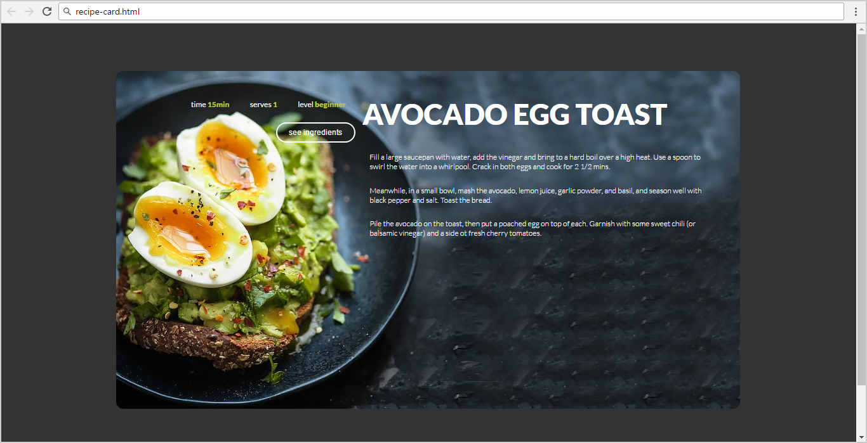

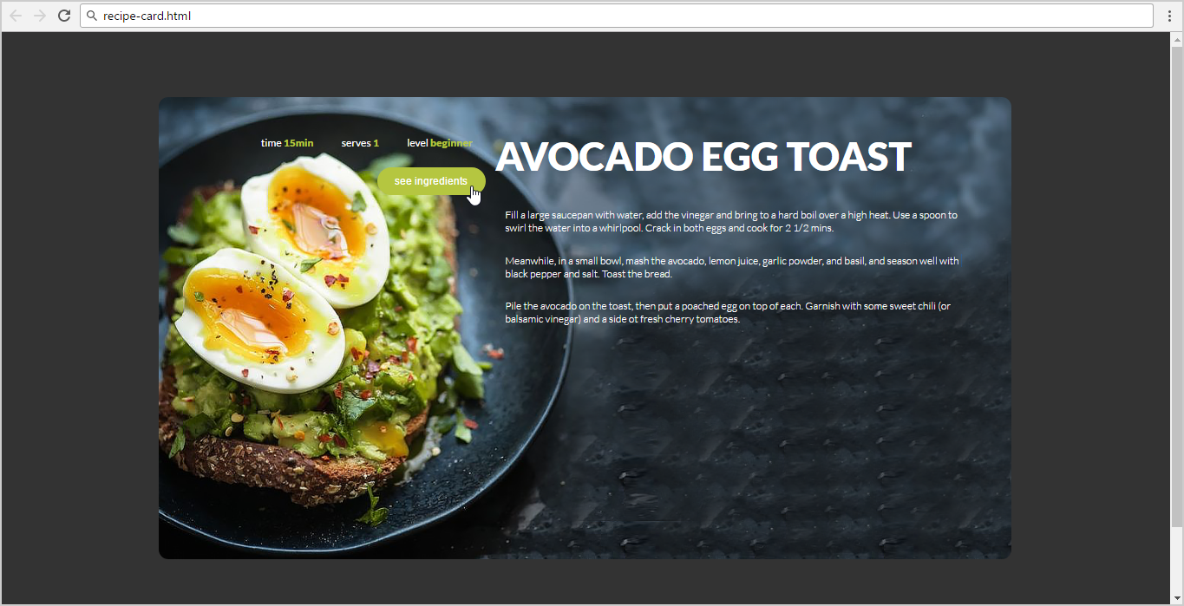

* Use the following HTML file as starting point: "**recipe-card.html**".
  + You are **NOT** allowed to change the HTML code.
* Create the CSS file: "**recipe-card.css**".

### Constraints

* Default font: 16px font-family:"Lato", sans-serif;[**"https://fonts.googleapis.com/css?family=Lato:300,400,900"**](https://fonts.googleapis.com/css?family=Lato:300,400,900)
* Default text color: #ffffff
* Text-color: #b5c640

### Hints

Use a **color picker** to catch certain colors.

## Web Agency

You are given the HTML for the Web page shown below as screenshots. Write the missing CSS:





* Use the following file: "**web-agency.html**".
  + You are **NOT** allowed to change the HTML code.
* Create file: "**web-agency.css**".

### Constraints

* As default font use “16px 'Lato', sans-serif”.
* Import the “**Lato**” font in your CSS from Google Fonts.
* As default color use “#333333”.

## Potato

You are given the HTML for the following Web page. Write the missing CSS:

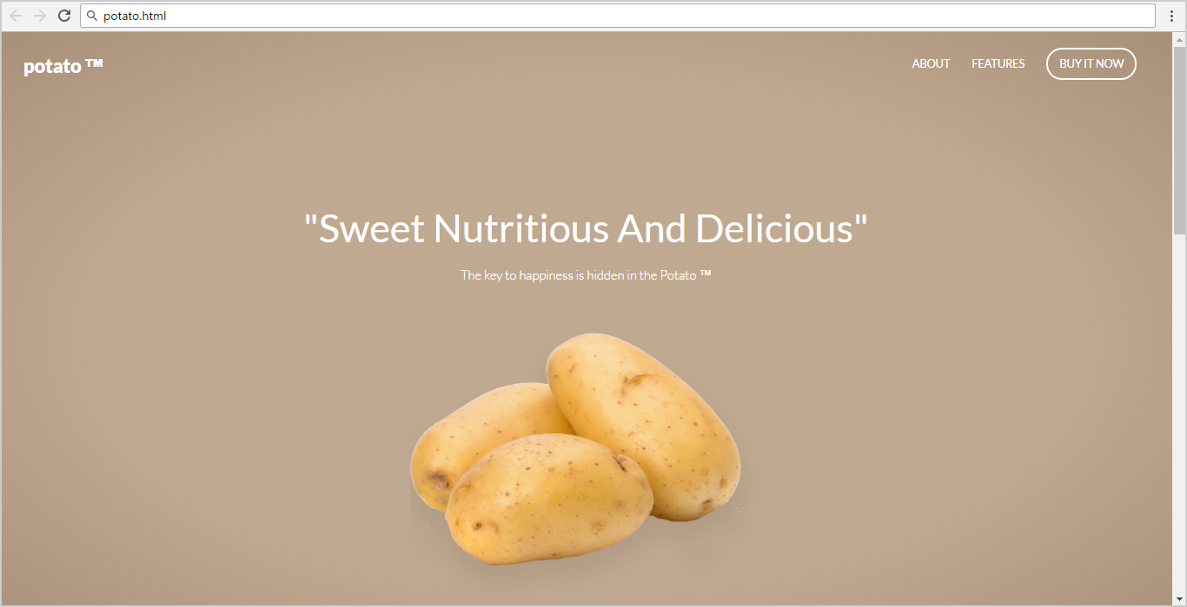

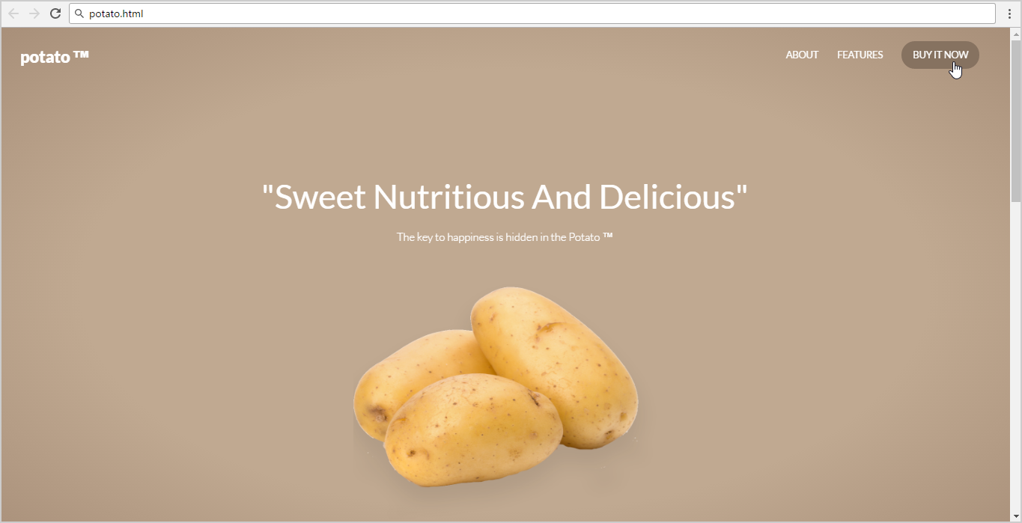

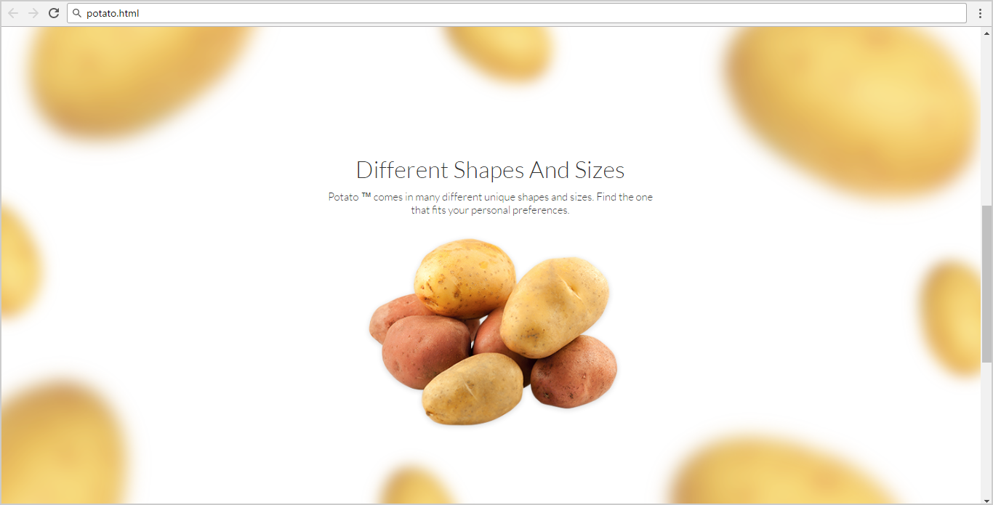

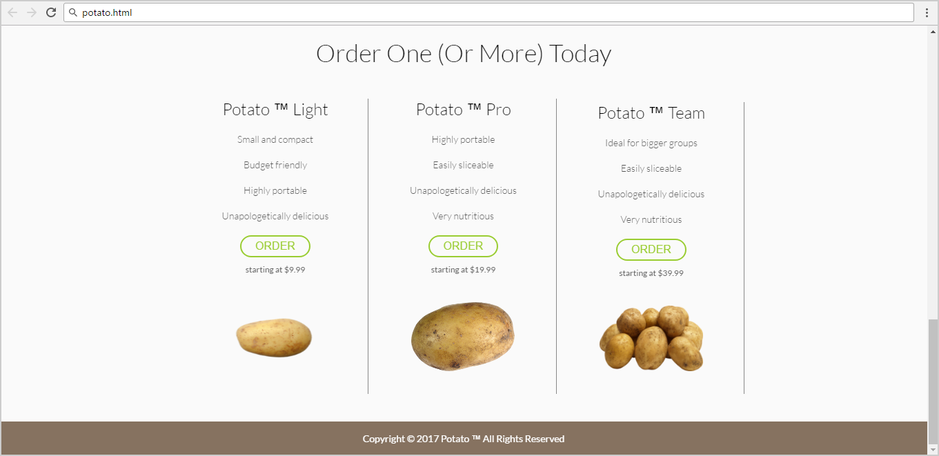

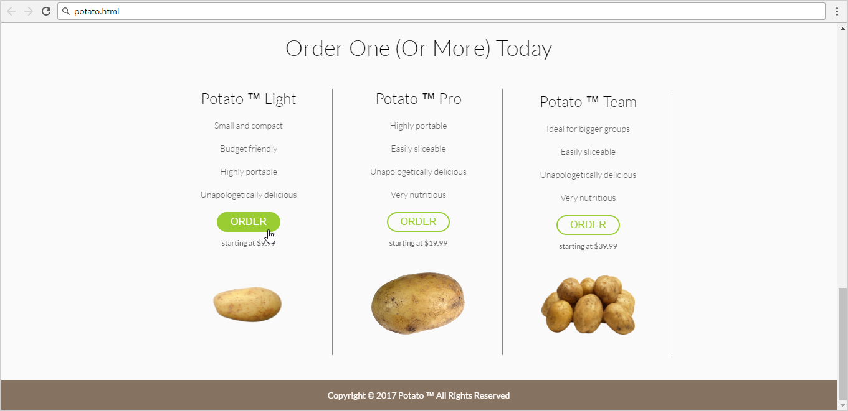

* Use the following HTML file as starting point: "**potato.html**".
  + You are **NOT** allowed to change the HTML code.
* Create the missing CSS file: "**potato.css**".

### Constraints

* Default font: 14px 'Lato', sans-serif;

### Hints

Use a **color picker** to catch certain colors.

Use for <header>

* background: **radial-gradient(ellipse at center,**

**rgba(192,169,145,1) 0%,  
 rgba(192,169,145,1) 59%,  
 rgba(168,143,121,1) 100%);**

1. **Color Kitchen**

Create a Web page like the shown below using the HTML coee from **"color-kitchen.html"**. Write the missing CSS.

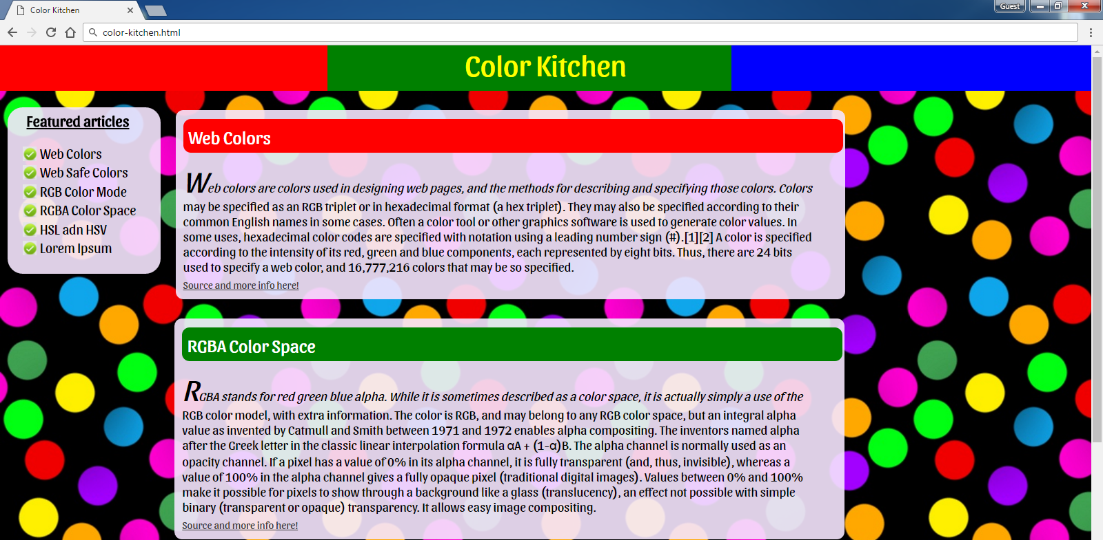 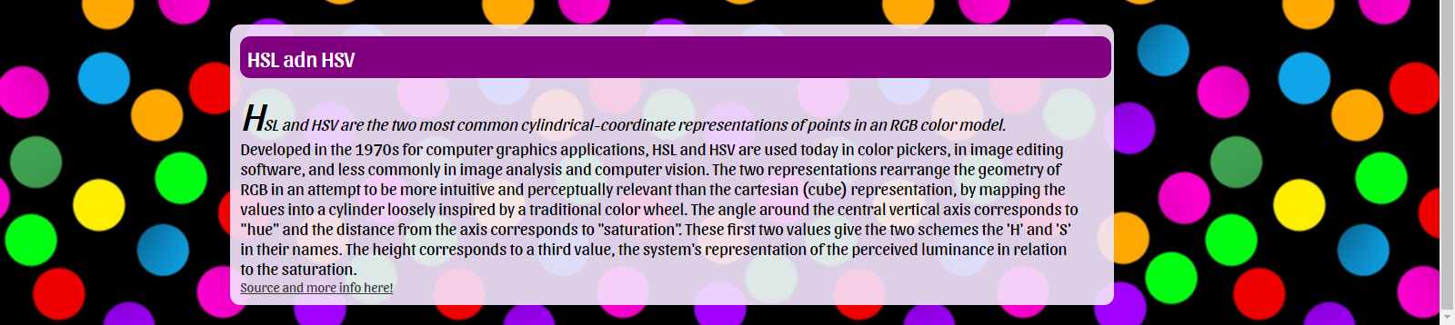

 

* Create the missing CSS file: "**color-kitchen.css**".
* You are **NOT** allowed to change the original HTML file.
* Default font: <https://fonts.googleapis.com/css?family=Sansita>
* Background-color: **rgba(245, 230, 254, 0.9)**
* Default: **font-size: 20px**

**Hints**

* Use **gradient generator** for header background colors (search in Internet).
* Use “rem” for specifying the font-size.

## “Plan” Page

You are given the HTML for the Web page shown below. Write the missing CSS:

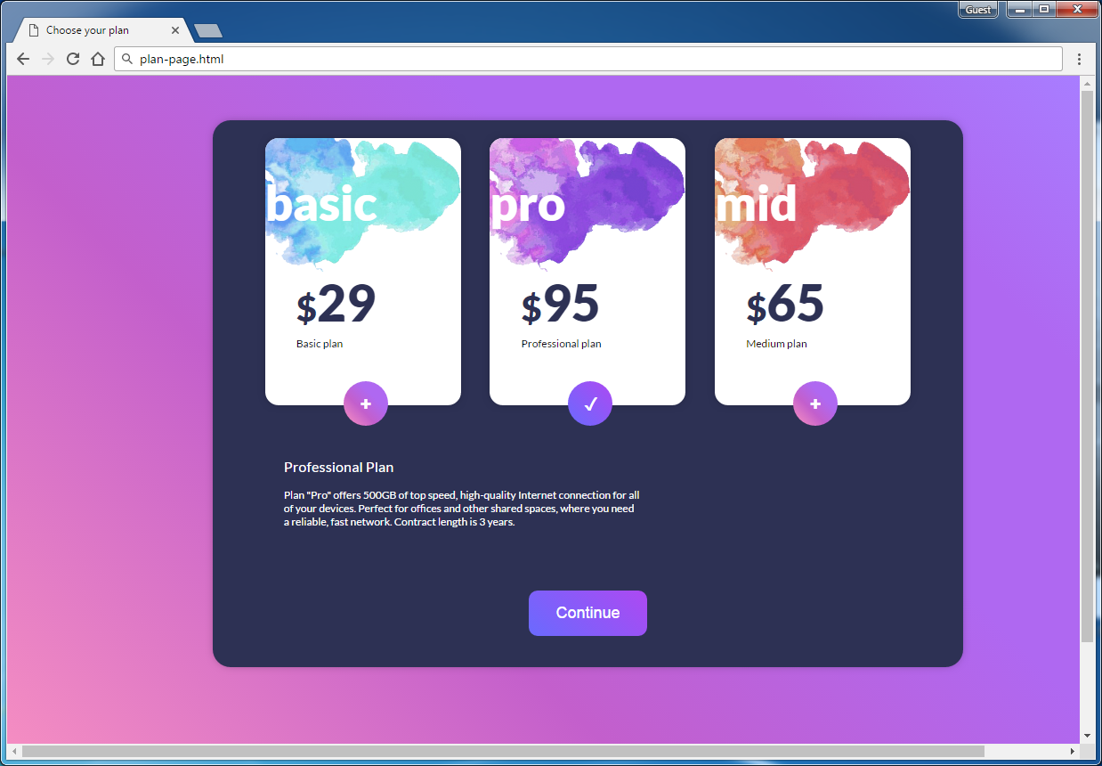

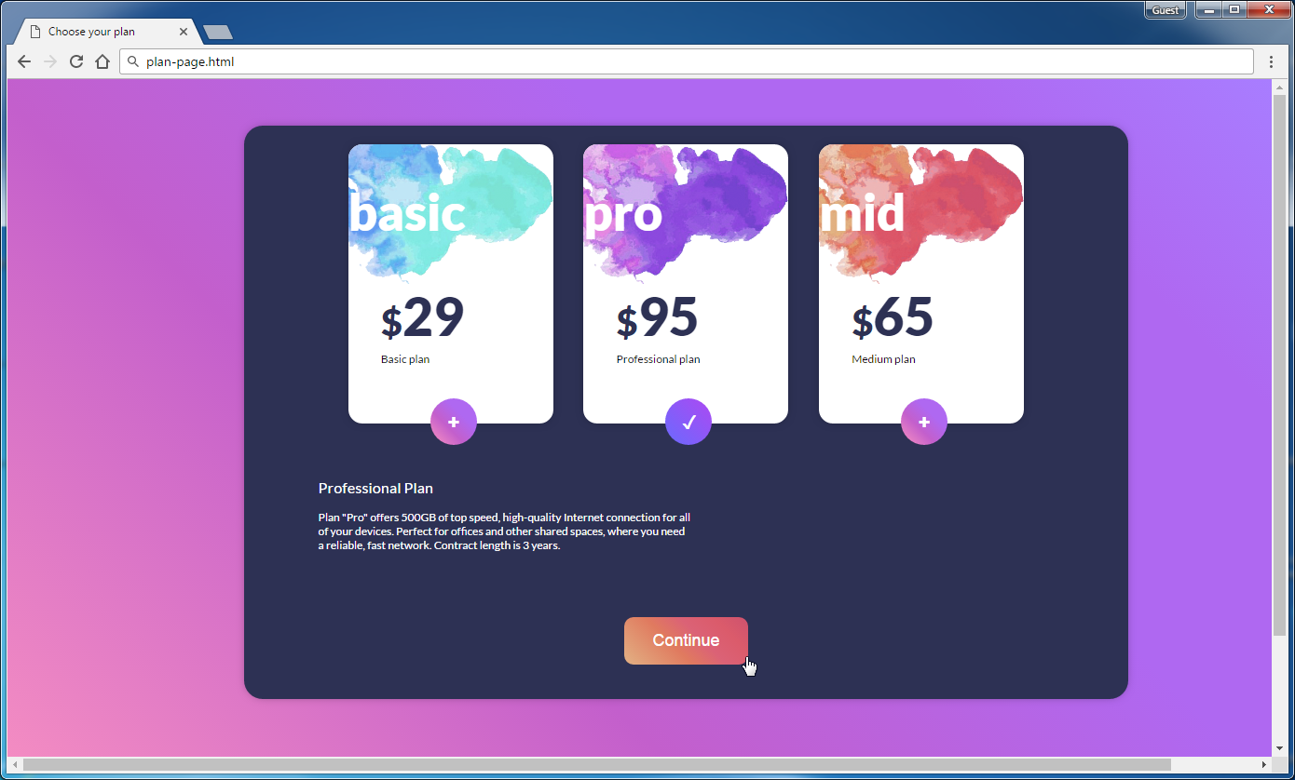

* Use the following HTML file: "plan-page.html".
  + You are **NOT** allowed to change the HTML code.
* Write the missing CSS file: "plan-page.css".

### Constraints

* As default font use “14px 'Lato', sans-serif”.
* Import the “**Lato**” font in your CSS from Google Fonts.

### Hints

Use a **color picker** to catch certain colors.

Use for <body>

* background: **linear-gradient(45deg,**

**rgba(253,149,192,1) 0%,  
 rgba(195,95,204,1) 38%,  
 rgba(175,104,241,1) 66%,** **rgba(175,104,241,1) 84%,  
 rgba(168,125,255,1) 100%);**